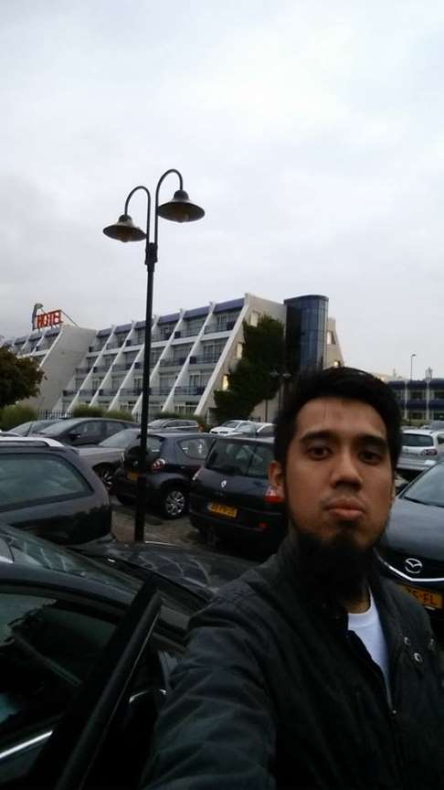© The Independent Singapore

**Singaporean accused of financing terrorism refuses to recognise Singapore courts jurisdiction**

Anna Maria

14/1/2020

Singapore—The court trial for Imran Kassim, the first Singaporean to be charged for financing terrorism started on Monday (Jan 13) with an admission from the accused that he donated S$450 to ISIS but that he claimed trial as he does not accept the laws of Singapore.

An investigation conducted by the Commercial Affairs Department discovered that Mr Imran had given the amount of S$450 to an individual in Turkey identified as Mohamad Alsaied Almidan on October 31, 2014, toward publishing propaganda for ISIS.

According to a statement from [the Ministry of Home Affairs (MHA)](https://www.mha.gov.sg/newsroom/press-release/news/singaporean-charged-for-financing-of-terrorism) in April of last year, the 36-year-old former managing director of logistics firm Novo Logistics was charged “for providing money to support ISIS’ propaganda efforts for terrorist purposes, an offence under section 4(b) of the Terrorism (Suppression of Financing) Act, Chapter 325.”

Mr Imran is scheduled to appear before District Judge Seah Chi-Ling on Tuesday (Jan 14) for the verdict to be read. He faces possibly 10 years in jail, a fine of S$500,000, or both.

***On Monday he told Judge Seah that he was choosing a trial over a guilty plea.***[***TODAY***](https://www.todayonline.com/singapore/i-recognise-only-syariah-law-singaporean-claims-trial-after-admitting-giving-s450-isis)***reports him as saying, “I don’t recognise Singapore laws, only Syariah (Islamic) law… The only thing I will do is I admit I did the transfer and did it to benefit the Islamic State.”***

According to Nicholas Khoo, the Deputy Public Prosecutor on the case, Mr Imran was fully aware that his donation would be used to gather even more support for and awareness of ISIS.

The DPP said, “Terrorism is a transnational scourge and Singapore takes its duties as a member of the global community seriously in its unending fight against terrorism and, accordingly, terrorism financing.”

Proof of Mr Imran’s donation to ISIS came in the form of Western Union records of the transfer, and Mr Imran’s own statements at the Commercial Affairs Department, which he said were given voluntarily.

Mr Imran told the court that he “made the transfer and did it to benefit the Islamic State,” but argued that the amount he had donated was “pretty small.” He said that he had given the money to protest “Singapore’s participation in the war against ISIS”.

Detained under the Internal Security Act (ISA) since 2017, Mr Imran was under investigation by the Internal Security Department and was issued with a Detention Order (DO) for intending to undertake armed violence overseas.

The statement from MHA reads, “This act of providing money in support of terrorist purposes is a serious offence, regardless of the amount, under the Terrorism (Suppression of Financing) Act.”

At the end of the statement, the MHA issued a warning against providing funds to terrorist groups. “Members of the public are reminded not to remit money, of any amount, or provide any support through the provision of services, supplies or any material to a terrorist organisation or any member of a terrorist group.”

Mr Imran was arrested in September of 2017. Back then, the MHA announced that he had been radicalised by the propaganda of Islamic State (IS).

The MHA said that Mr Imran had tried to join IS in Syria at least twice and that he has been prepared to attack personnel from SAF (Singapore Armed Forces) in a global anti-IS coalition or to detain them as hostages.

Mr Imran has also wanted to join the pro-IS forces in Malawi, in the Philippines, and that he has used multiple accounts on social media to promote pro-IS materials. -/TISG

**More on MSN News:**