**One person killed, two injured in stabbing attack in Paris suburb**

**By Arnaud Siad and**[**Ivana Kottasová**](https://edition.cnn.com/profiles/ivana-kottasova)**, CNN**

Updated 1957 GMT (0357 HKT) January 3, 2020

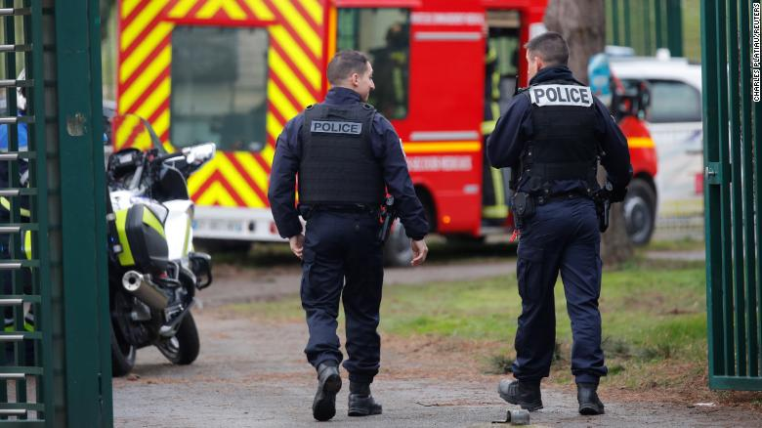

French police secure an area in Villejuif near Paris on January 3, 2020.

**(CNN)**One person was killed and two were injured in a stabbing attack in a Paris suburb Friday, a French government official confirmed.

Police killed the attacker, who stabbed people in a park in the suburb of Villejuif, south of Paris, French news channel BFM TV quoted Laurent Nunez, the secretary of state to the interior minister, as saying.

Nunez said the police had interrupted "a killing spree."

Loïc Travers, the secretary of the National Police Alliance for the Ile-de-France region, told BFM TV the attack took place around 2 p.m. in Villejuif (8 a.m. ET).

The attacker has so far only been described as male.

Laure Beccuau, prosecutor of the Creteil commune southeast of Paris, told French news agency AFP that the man had tried to stab others, but they "managed to evade him."

The attacker fled the park to a supermarket in neighboring suburb of Hay-les-Roses, where he "apparently intended to continue his attacks," Hay-les-Roses Mayor Vincent Jeanbrun told BFM TV.

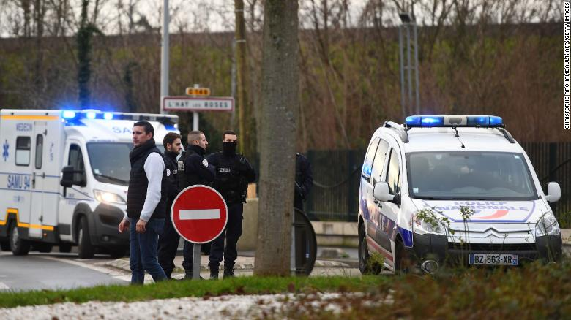

Police at the park in Villejuif, France, where the attack took place.

"Fortunately, the police were quickly alerted and made their way quickly to the scene where they neutralized him by killing him," Jeanbrun said.

Police have opened an investigation into the stabbings. The assailant's motive is not yet known.

The stabbing was carried out just days before the fifth anniversary of attacks in Paris targeting the satirical magazine Charlie Hebdo, a kosher grocery and the suburb of Montrouge, which left 17 people dead.

France has remained on high alert since a string of terror attacks in 2015, the deadliest of was the [November 2015 attacks on six locations](https://www.cnn.com/2015/12/08/europe/2015-paris-terror-attacks-fast-facts/index.html) across Paris, including on a crowded concert venue, which left 130 dead.

According to AFP, France's anti-terror prosecutor Jean-Francois Ricard was on the scene of the attack Friday, but the investigation is being carried out by the Creteil prosecutor's office.

*CNN's Sebastian Shukla contributed to this article.*