[**Singapore**](https://www.channelnewsasia.com/category/singapore)

**Self-radicalisation main terror threat in Singapore; far-right extremism an emerging concern: ISD report**



A man using a laptop. (File photo: Jeremy Long)

[](https://www.channelnewsasia.com/author/chew-hui-min)

[**Chew Hui Min**](https://www.channelnewsasia.com/author/chew-hui-min)

[@ChewHuiMinCNA](https://twitter.com/ChewHuiMinCNA)

23 Jun 2021 12:00PM(Updated: 23 Jun 2021 01:55PM)

SINGAPORE: Self-radicalised actors influenced by extremist materials online are the main domestic terrorism threat facing Singapore, the Internal Security Department (ISD) said in a report released on Wednesday (Jun 23).

And while Islamist terrorism remains the primary concern, far-right extremism is an emerging threat, it said in the Singapore Terrorism Threat Assessment Report 2021.

ISD assessed that there is currently no specific nor credible intelligence of an imminent terrorist attack against Singapore, but the terrorism threat to Singapore remains high.

"Globally, terrorist activities have persisted amid the ongoing COVID-19 pandemic, with terrorist recruitment and propaganda efforts stepped up online," said ISD.

ISD said that 54 people have been dealt with under the Internal Security Act (ISA) for terrorism-related conduct since 2015. Of these, 44 were self-radicalised.

Over the last two years, 14 out of 16 people issued with terrorism-related ISA orders were self-radicalised. They include 10 Singaporeans and four foreigners - three Indonesians and a Bangladeshi who were working in Singapore.

The majority of the 14 self-radicalised individuals were supporters of Islamic State.

"Most of them remained staunchly supportive of ISIS (Islamic State in Iraq and Syria) even with the group’s territorial losses and eventual military defeat," said the report.

Two individuals were inspired by other causes.

One of the 14 is a 16-year-old Singaporean who was inspired by far-right extremist ideology - the first such case detected in Singapore. He had targeted two mosques in planned copycat attacks of New Zealand's Christchurch attacks.

Overseas, far-right extremist groups have reportedly become more organised and capable of mounting attacks. However, ISD said that there is currently no indication that far-right extremism has gained significant traction in Singapore.

"However, this does not mean that we are immune to far-right/anti-Islam ideologies, which are prevalent on social media," it said.

"We have to stay vigilant and take a firm stand against any rhetoric that promotes hatred or animosity towards other communities, and draw the line at the pursuit of any violent action, regardless of how it is justified."

It noted that there is a also wider trend in recent years for lone actors to use "easily available means", such as knives and vehicles, in terrorist attacks. While Singapore has strict regulations on firearms, attackers can resort to weaponising readily accessible items.

Machete which 16-year-old youth intended to purchase for his attack against Muslims at two mosques. (Photo: Ministry of Home Affairs)

Another case not linked to Islamic State was a 20-year-old Singaporean - the first self-radicalised individual detained under the ISA who was primarily driven by the Israel-Palestine conflict.

A detention order under the ISA was issued against him on Mar 5 this year.

He had wanted to travel to Gaza in the Palestinian territories to join Hamas’ military wing in its fight against Israel. He had also made plans and preparations to attack Jews at a synagogue.

**EXTERNAL THREATS**

Within Southeast Asia, Islamic State remains the primary terrorism threat actor, said ISD. The region remains part of Islamic State's decentralised "global caliphate", with southern Philippines and Myanmar’s Rakhine state as potential theatres of extremism.

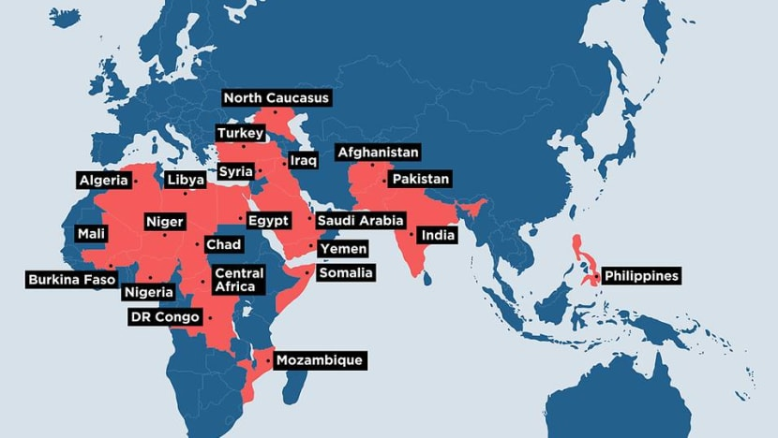ISIS' declared wilayah (provinces) around the world. (Source: Ministry of Home Affairs)

The number and scale of terror attacks and plots by regional pro-Islamic State terror groups fell in 2019 and 2020 due to strong counter-terrorism measures and COVID-19 travel restrictions also appeared to have hampered the movement of terrorists in the region.

But despite losing its last territorial stronghold in March 2019, the terror group remains an active insurgent force in Syria and Iraq.

"It reportedly still has some 10,000 fighters in the conflict zone and tens of millions of dollars in cash reserves," said the report.

"Over the past year, ISIS has escalated its insurgent activities in the conflict zone, taking advantage of the security vacuum left by reduced military operations due to COVID-19 and the reduction in US troops in Iraq."

Since the demise of its so-called caliphate, Islamic State has repositioned its propaganda narrative, calling it a “battle of attrition”.

"In line with this narrative, it has stepped up calls for its affiliates and supporters worldwide to conduct attacks wherever they are."

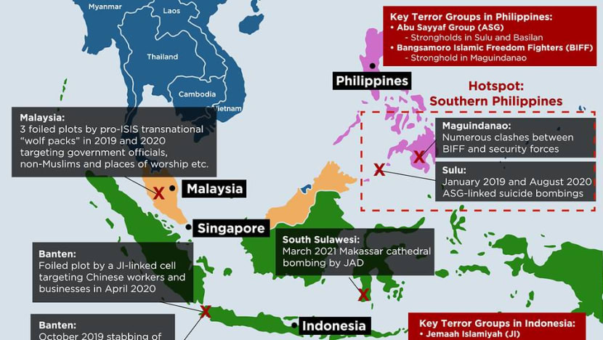The "Islamist terrorism" threat in Southeast Asia. (Source: Ministry of Home Affairs)

Jemaah Islamiyah, the terrorist group aligned with Al-Qaeda remains a latent terror threat, ISD said. There are recent signs that it is rebuilding its military capabilities and may re-engage in terrorist violence in Indonesia.

ISD said that it remains on high alert although there is no specific or credible intelligence of an imminent terrorist attack against Singapore.

"The recent cases involving the two Singaporean youths who had made detailed plans and preparations to kill Muslims and Jews in Singapore, are a sobering reminder that the threat of lone actor attacks remains very real," it said.

As Singapore is an open society, Singaporeans are susceptible to being influenced by external developments and events abroad can have an impact on the domestic security landscape, it added.

*Source: CNA/hm(rw)*