**UPDATE: Bomb attack kills 3, injures 20 in Afgooye**

65Shares

 Share

 Tweet

 Share

  
Saturday January 18, 2020

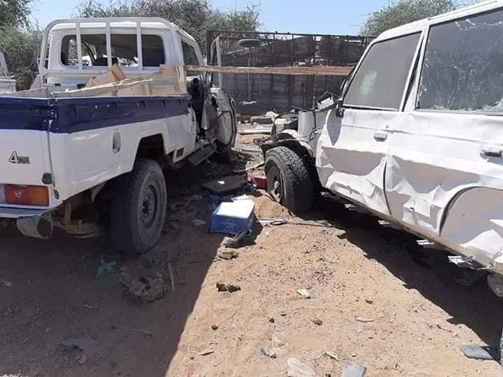

**MOGADISHU (HOL)** - Three people were killed and about 20 others injured Saturday following a car bomb explosion in Afgooye area.

Ads By Google

Sources said the car loaded with explosives targeting a police convoy escorting Turkish road contractors went off leaving death and destruction.

Turkish news outlet Anadolu said Turkish embassy officials in Mogadishu confirmed that four Turkish nationals involved in the road construction were injured in the early afternoon attack.

The militant group Al-Shabaab which claimed responsibility for the December 28 bombing which killed 89 people has carried out sustained attacks in the past against Turkish engineers.

The Turkish firm is constructing the Mogadishu-Afgooye road funded by the Qatari government.  
No group has claimed responsibility for today’s attack.